A city is represented as a **bi-directional connected** graph with n vertices where each vertex is labeled from 1 to n (**inclusive**). The edges in the graph are represented as a 2D integer array edges, where each edges[i] = [ui, vi] denotes a bi-directional edge between vertex ui and vertex vi. Every vertex pair is connected by **at most one** edge, and no vertex has an edge to itself. The time taken to traverse any edge is time minutes.

Each vertex has a traffic signal which changes its color from **green** to **red** and vice versa every change minutes. All signals change **at the same time**. You can enter a vertex at **any time**, but can leave a vertex **only when the signal is green**. You **cannot wait**at a vertex if the signal is **green**.

The **second minimum value** is defined as the smallest value**strictly larger**than the minimum value.

* For example the second minimum value of [2, 3, 4] is 3, and the second minimum value of [2, 2, 4] is 4.

Given n, edges, time, and change, return *the****second minimum time****it will take to go from vertex*1*to vertex*n.

**Notes:**

* You can go through any vertex **any** number of times, **including** 1 and n.
* You can assume that when the journey **starts**, all signals have just turned **green**.

**Example 1:**

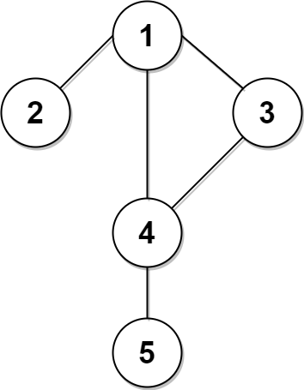        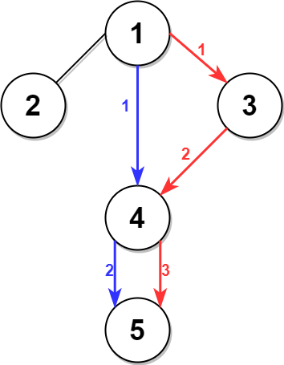

**Input:** n = 5, edges = [[1,2],[1,3],[1,4],[3,4],[4,5]], time = 3, change = 5

**Output:** 13

**Explanation:**

The figure on the left shows the given graph.

The blue path in the figure on the right is the minimum time path.

The time taken is:

- Start at 1, time elapsed=0

- 1 -> 4: 3 minutes, time elapsed=3

- 4 -> 5: 3 minutes, time elapsed=6

Hence the minimum time needed is 6 minutes.

The red path shows the path to get the second minimum time.

- Start at 1, time elapsed=0

- 1 -> 3: 3 minutes, time elapsed=3

- 3 -> 4: 3 minutes, time elapsed=6

- Wait at 4 for 4 minutes, time elapsed=10

- 4 -> 5: 3 minutes, time elapsed=13

Hence the second minimum time is 13 minutes.

**Example 2:**

**Input:** n = 2, edges = [[1,2]], time = 3, change = 2

**Output:** 11

**Explanation:**

The minimum time path is 1 -> 2 with time = 3 minutes.

The second minimum time path is 1 -> 2 -> 1 -> 2 with time = 11 minutes.

**Constraints:**

* 2 <= n <= 104
* n - 1 <= edges.length <= min(2 * 104, n * (n - 1) / 2)
* edges[i].length == 2
* 1 <= ui, vi <= n
* ui != vi
* There are no duplicate edges.
* Each vertex can be reached directly or indirectly from every other vertex.
* 1 <= time, change <= 103